**Date of Experiment: 14/4//25**

**Date of Submission:14/4/25**

**SVKM’S NMIMS**

**Mukesh Patel School of Technology Management & Engineering**

Department of Computer Engineering

Subject- Robotic Process Automation

**EXPERIMENT NO. 10**

**Objective:** The objective of this procedure is to create a model-driven app for ____________________________ (fill it as per your model app that you have designed)

**Material Required:**

* Access to Power Platform environment
* PowerApps Studio
* Power Automate (Flow)

**Scenario:** Describe the Scenario

**Theory:** Model-driven apps in PowerApps allow users to create sophisticated, data-centric applications without writing code. These apps are built on a relational data model, where entities (tables) represent different business objects, and relationships define how these entities are connected.

**Procedure:**

1. **Create a Solution:**
   * Open PowerApps Studio and create a new solution named "___________________".
2. **Create Publisher:**
   * Click on "New Publisher" and create a publisher using your name with initials as the prefix.
3. **Create Course Table:**
   * Create a new table named "Course".
   * Add the following columns:

____________________________________

____________________________________

____________________________________

1. **Auto-creation of Contact Table:**
   * Upon creating the instructor field, it automatically adds the Contact table.
   * Add the following columns to the Contact table:

_____________________________________

_____________________________________

1. **Create Views:**

_____________________________________

_____________________________________

1. **Create new form:**
   * In the course table click on form
   * Click on New Form on the top
   * And select main form
2. Similarly add the steps that are required in your experiment.
3. **Create Model-Driven App:**
   * From the PowerApps Studio, create a new Model-Driven App.
   * Add existing tables: ___________________________
   * Customize app layout and navigation.
4. **Testing:**
   * Test the app to ensure all functionalities work as intended.
   * Verify data input, approval process, and navigation flow.

**Screenshots of _____________________ (Create the Different Sections for Screenshots)**

Application columns:

Business Process Flow:

**Screenshots of Final app:**

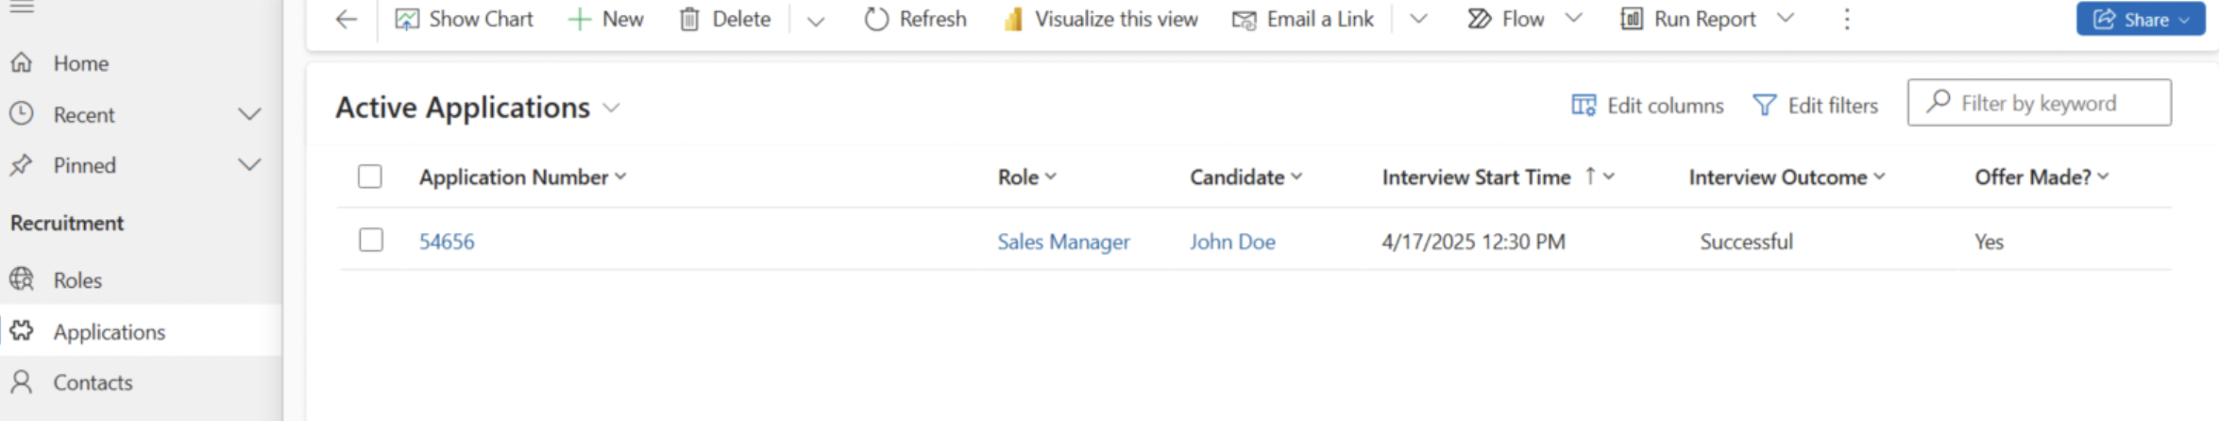

**Conclusion:**

**Successfully implemented a module-driven app in Power Apps.**

**Reference:**

[**https://www.youtube.com/watch?v=HrILchHvMUA&t=2922s**](https://www.youtube.com/watch?v=HrILchHvMUA&t=2922s)